A MINI PROJECT
ON
THE DATASET: HEALTHCARE DIABETES
BY
DUKE, LEAH ODO
TRACK NO: 22/132011

DEPARTMENT OF
THE DEPARTMENT OF MATHEMATICS AND COMPUTER SCIENCE

SUBMITTED TO
DR.SYLVIA OLADEMEJI

FACULTY OF NATURAL AND APPLIED SCIENCES
ARTHUR JARVIS UNIVERSITY, AKPABUYO, CROSS RIVER STATE

FEBURARY,2026..

Overview
This analysis is based on a dataset titled "Healthcare-Diabetes.csv", which contains patient health metrics used to determine diabetes outcomes. The dataset includes the following variables:
​Id: Unique identifier for each entry.
​Pregnancies: Number of times pregnant.
​Glucose: Plasma glucose concentration.
​Blood Pressure: Diastolic blood pressure (mm Hg).
​Skin Thickness: Triceps skin fold thickness (mm).
​Insulin: 2-Hour serum insulin (mu U/ml).
​BMI: Body mass index (weight in kg/
(height in m)^2).
​Diabetes Pedigree Function: Diabetes pedigree function.
​Age: Patient age in years.
​Outcome: Class variable (0 or 1) indicating diabetes presence.

Dataset Used
The dataset used in this analysis contains healthcare records of patients, including demographic and clinical information. It consists of approximately 1582 records with 10 attributes.
The analysis was conducted using Python in a Google colab Notebook environment. The dataset was loaded and inspected to understand its structure and contents. Exploratory Data Analysis (EDA) techniques were applied, and data visualization was performed using Matplotlib library.
​The data was loaded using the pandas library in Python. The notebook demonstrates the initial data retrieval and printing of the full data frame to verify the contents.
Three types of visualizations were used in this study: a histogram, a bar chart, and a scatter plot.

Data Analysis and Visualization
Effects of BMI on glucose level (Scatter Plot)
A scatter plot shows the relationship between a patient’s BMI and their glucose levels. It proves whether people with higher body mass index tend to have higher sugar levels, helping to identify health patterns.

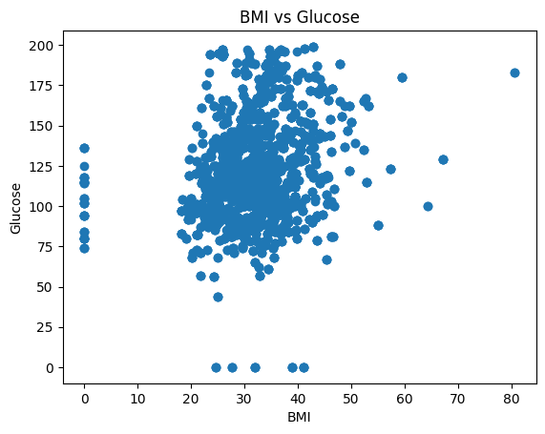

Diabetes Outcome count (Bar Chart)
A bar chart was used to represent how many people in the data recorded in the dataset have diabetes versus those who don’t. It proves whether the dataset is balanced or if one group is much larger than the other.
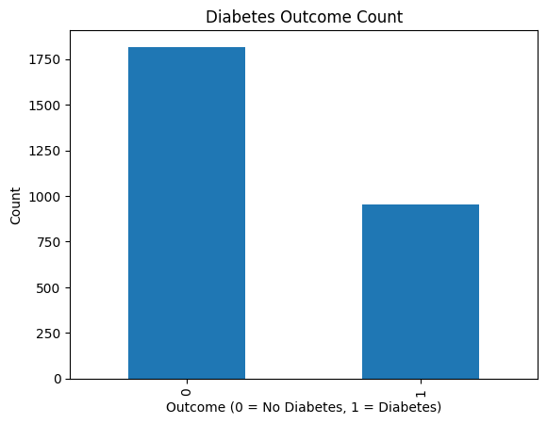

Distribution of glucose levels (Histogram)
The Histogram shows how a specific health factor, like Glucose or Blood Pressure, is spread across all patients. It proves where the "average" health level lies and reveals if there are any unusual or extreme values in the data.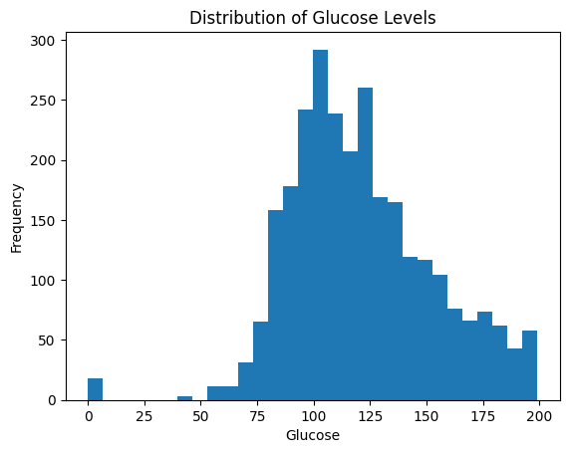

Findings
From the analysis and visualizations:
- All the patients are pregnant women.
- The patient records cover a wide age range, with glucose levels and BMI showing significant variability.
- Key diagnostic indicators such as Glucose and Insulin levels appear to be primary markers in the clinical assessment.
These findings emphasize the importance of focusing healthcare resources on prevalent conditions.
Conclusion
In conclusion, the visualizations in this notebook are doing exploratory data analysis (EDA) to find patterns and proving which physiological markers are the most significant indicators of diabetes in the patient population.

References
- Dataset Set used - https://www.kaggle.com/datasets/nanditapore/healthcare-diabetes

